Edinburgh Futures Resource Hub
Learn skills, share skills, and have fun!

 | Workshop | Time
Monday | Breakfast Club  Computer Drop In | 11-1
 | Closed from 1-2
 | Financial Skills  Arts and Crafts | 2-5  2-5
Tuesday | Baking | 11-1
 | Closed from 1-2
 | Woman’s Group  Computer Drop In | 2-4  2-5
Wednesday | Arts and Crafts  IT Skills | 11-1  11-1
 | Closed from 1-2
 | Music Group  General Drop In | 2-5  2-5
Thursday | Walking Group  Mindfulness | 11-1
 | Closed from 1-2
 | Goals setting  Games/Film Club | 2-4  4-7
Friday | Arts and Crafts  IT Skills | 11-1
 | Closed from 1-2
 | Ready Steady Cook  Mindfulness | 2-5  2-5
Saturday | TBC | 11-2
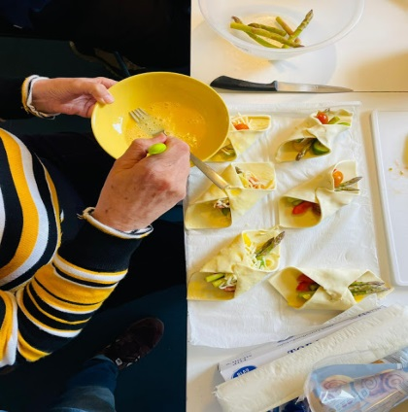
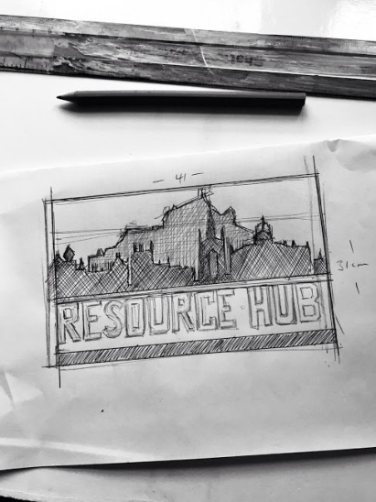

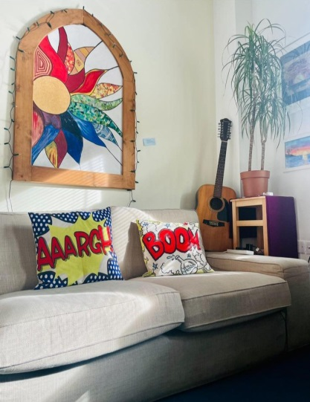
Just drop in – no need to call beforehand
3 Gilmour St
Edinburgh
EH8 9HR
0131 667 9407

